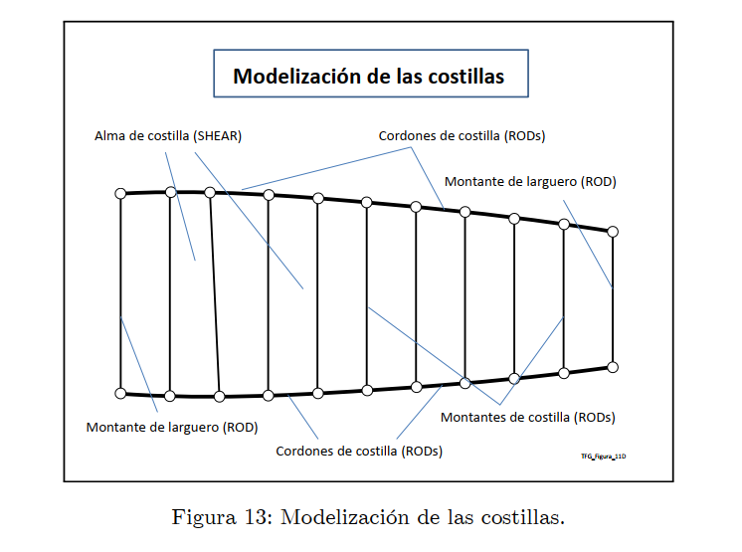
This is from the guide (image). You mentioned that shear should be constructed by two nodes. How can I do that when it is implied that it is like a surface in the guide?
ChatGPT said:
Thank you for sharing the image! It helps clarify the situation. The shear webs (referred to as "Alma de costilla") are indeed intended to behave like surfaces to model the distribution of shear loads, but this can still be represented in a simplified way using SHEAR elements in Nastran, which are defined by two nodes. Here's how this works and how to properly model it:

Understanding the Discrepancy Between Surface and Element Definition
- In theory, the guide describes the shear web as a continuous surface capable of transferring shear loads across its area.
- In Nastran, the SHEAR element simplifies this by approximating the shear behavior between two nodes. It does not explicitly define an entire surface but instead models the shear stiffness between node pairs.
- If you need to represent the shear web as a true surface, you would use CQUAD4 (or CQUADR) shell elements instead of SHEAR elements. However, SHEAR elements are often preferred for simplicity when focusing only on shear transfer.

Steps to Model the Shear Web (Alma de Costilla)
Option 1: Using SHEAR Elements
- Define Nodes Along the Shear Web Boundary:
  - Place nodes at the boundaries of the ribs where the cordones de costilla (RODs) intersect with the montantes de costilla (vertical RODs).
  - These nodes represent the connection points of the shear web.
- Create SHEAR Elements Between Adjacent Nodes:
  - For each adjacent pair of nodes along the shear web boundary, define a SHEAR element.
  - Each SHEAR element will approximate the shear stiffness of a small portion of the web.
Example Nastran Card:
plaintext
CopyEdit
SHEAR 1 101 10 11
  - 1: Element ID
  - 101: Property ID (referencing PSHEAR)
  - 10, 11: Node IDs of the adjacent nodes
- Define Shear Properties Using PSHEAR:
  - The PSHEAR card defines the shear panel's stiffness properties:
plaintext
CopyEdit
PSHEAR 101 MID T
  - 101: Property ID
  - MID: Material ID (referencing the material card)
  - T: Thickness of the shear web
Option 2: Using CQUAD4 Elements (Shell Elements for True Surface Modeling)
- Mesh the Shear Web as a Surface:
  - Instead of defining only the boundary nodes, create a surface mesh (using quads or triangles) that covers the entire shear web.
  - Use CQUAD4 (or CTRIA3) elements to represent the surface.
- Define Material and Thickness Properties:
  - Use a PSHELL card to define the thickness and material properties:
plaintext
CopyEdit
PSHELL 201 MID T
  - 201: Property ID
  - MID: Material ID
  - T: Thickness of the web
- Advantages of CQUAD4 Over SHEAR:
  - CQUAD4 gives a more detailed representation of the stress and strain distribution across the web.
  - It allows for visualization of stresses (e.g., von Mises) and better integration with other parts of the structure.

When to Use Each Option
- SHEAR Elements (Option 1):
  - Use this when simplicity is key, and you only care about shear stiffness between nodes (not detailed stress results).
  - Ideal for conceptual studies or when computational cost is a concern.
- CQUAD4 Elements (Option 2):
  - Use this when a more detailed representation of the shear web is required.
  - Essential if you need to calculate stress distributions, buckling, or deformations in the web.

Recommendation for Your Case
Since the image implies a surface-like behavior, I recommend using CQUAD4 elements (Option 2) if computational resources allow. This will ensure that the shear webs are modeled as true surfaces, providing more realistic results for stress and load distribution. However, if simplicity is preferred, SHEAR elements (Option 1) are a valid approximation.
Would you like a step-by-step guide on setting up CQUAD4 elements or additional clarification on the PSHEAR properties? 🚀

